
BRAC University (Department of Computer Science and Engineering)
CSE 470 (Software Engineering) | Summer 2025

Quiz 3
Student ID:
Section: 18,19 Full Marks: 20

Name: Duration: 30 minutes

1. Consider this pseudocode:
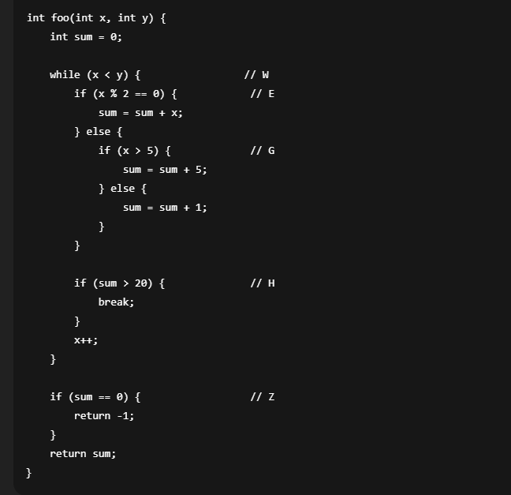

a)Draw the CFG of the code block. 5
b)Compute the cyclomatic complexity M. 2
c)List a basis set of independent paths. 2
d)How many test cases are needed for complete basis-path coverage? 1

Solution:
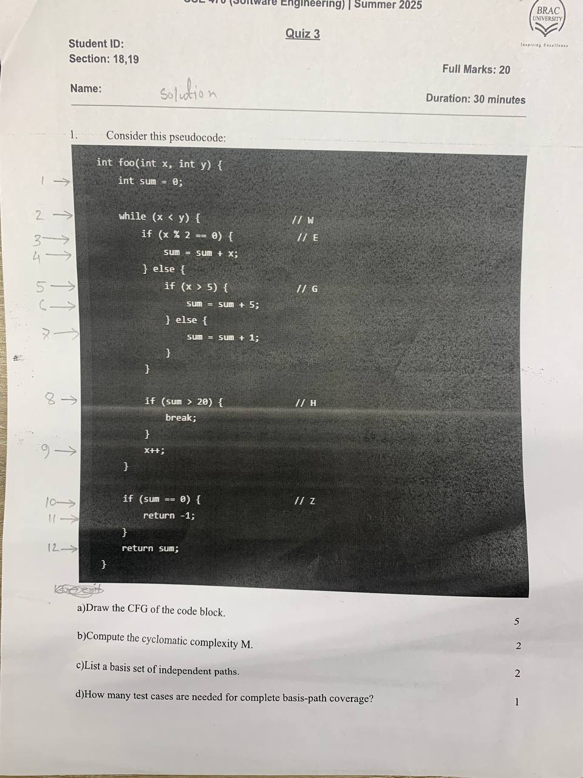

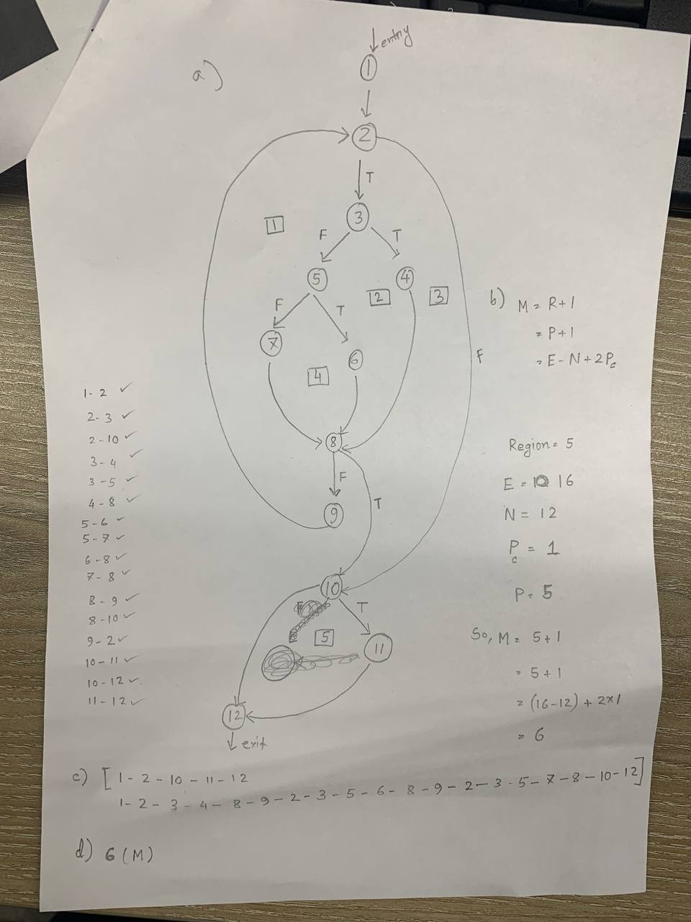

2.You are given the following Python code:
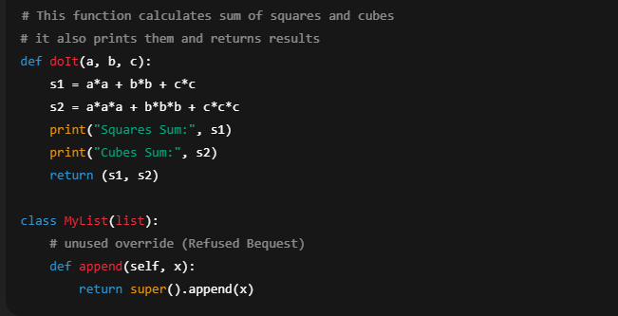

- Identify code smells present in the snippet (choose from: Inappropriate Naming, Comment, Duplicated Code, Long Method, Feature Envy, Refused Bequest). 5
- Refactor the code to remove the smells and improve readability. 5
